yellow.brick.way
- 4,151 followers
- 1,986 following
Yellow Brick Way
By Salonie Patel
Affiliated with Trinity College London
A centre for Communication Skills, Speech, Drama and Reading in
...
more



Top of Form
Bottom of Form



Restaurants

Hotels

Things to do

Transit

Parking

Pharmacies

ATMs

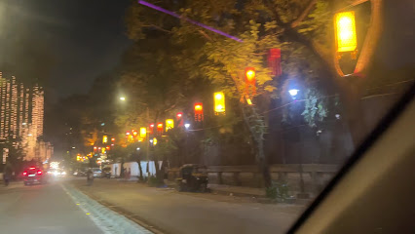

See photos

Yellow Brick Way by Salonie Patel

येलो ब्रिक वे बाय सलोनी पटेल
4.8(4)
Drama school
Overview
Reviews
About

Directions

Save
_
Nearby

Send to phone

Share


3 Varad 12th road, New Indian Society Rd, JVPD Scheme, Juhu, Mumbai, Maharashtra 400049


Open · Closes 7:30 pm


instagram.com




098201 99926




4R4H+R3 Mumbai, Maharashtra



Your Maps history
Add a label

Suggest an edit

Photos & videos
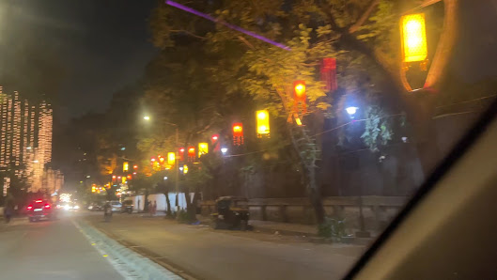
All
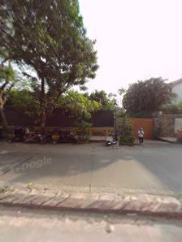
Street View & 360°

Videos

Add photos & videos

Review summary

5
4
3
2
1
4.8
4 reviews

Write a review

Reviews

Sort

Mona Sane
Local Guide · 7 reviews · 11 photos

8 years ago
Great concept n lush green place Must visit
Like
Share


Santosh Verma
1 review

2 years ago
Best Class Etcher
Translated by Google ・ See original (English)
Like
Share


Deepak Sah

4 months ago

More reviews (1)

People also search for
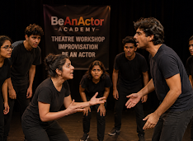
BeAnActor Academy
4.8
(29)
Drama school
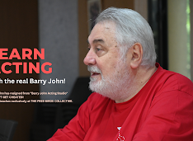
Barry John's Free Birds | The Free Birds Collective
4.9
(59)
Drama school

Hindi Diction Classes (BeAnActor)
4.9
(8)
Drama school
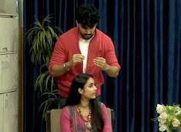
Barry John Acting Studio
4.4
(163)
Drama school

Web results

About this data

Meta
About
Blog
Jobs
Help
API
Privacy
Terms
Locations
Popular
Instagram Lite
Meta AI
Threads
Contact Uploading & Non-Users
Meta Verified
English
© 2026 Instagram from Meta

